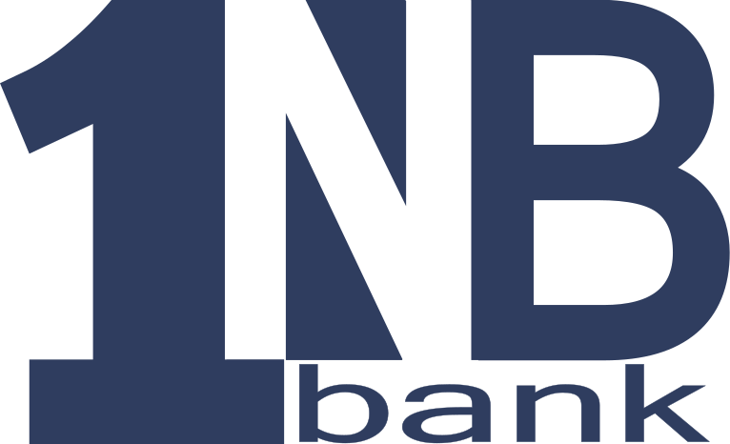
1NB Bank
DIRECT DEPOSIT/AUTOMATIC PAYMENT
ENROLLMENT AUTHORIZATION FORM

Let us help you switch your direct deposits and automatic payments to 1NB BANK! Complete and sign one form for each deposit or payment and mail to the companies you currently authorize to make direct deposits to or automatic payments from your bank account. This form will notify the companies that you wish to have your direct deposit transaction or automatic payment redirected to 1NB BANK. We can assist you in completing this form. Just stop by one of our convenient locations.

To: Company Name | From: Customer/Business Name
Company Address | Customer/Business Address
City, State, Zip Code | City, State, Zip Code
Company Account Number for Automatic Payments or ID Number for Direct Deposits | Customer Daytime Phone Number

Please redirect my Direct Deposit/Automatic Payment to 1NB BANK. I hereby authorize
(Company Name) to initiate credit entries (direct deposits)/debit entries (automatic payments) and, if necessary, adjustments for any error to my account indicated below and authorize 1NB BANK to credit and/or debit the same to such account I understand that this authorization is to remain in full force and effect until company listed above and 1NB BANK have received notification from me of its termination and have had a reasonable opportunity to act on it.

My new 1NB BANK information is listed below:

Signature Date

1NB BANK Checking Account Number

081906505
1NB BANK ABA/Routing Number

